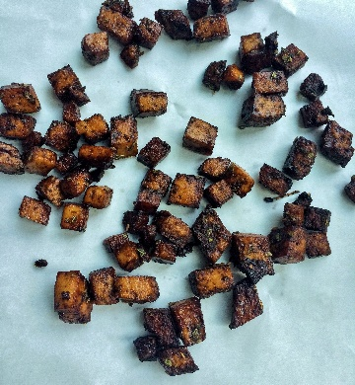

 **Crispy Baked Tofu**

*Serves 4*

**Ingredients**

1 container extra firm tofu

1 tbsp cornstarch

Balsamic Vinegar Marinade:

1/3 cup balsamic vinegar

1 tbsp olive oil

½ tsp oregano

½ tsp rosemary or thyme

½ tsp garlic powder or 1 garlic clove, minced

~5 fresh basil leaves, shredded

**Directions**

1. Preheat oven to 400°.
2. Mix all of the balsamic vinegar marinade in a Tupperware.
3. Drain the tofu and cut into 2 pieces. Wrap tofu in a kitchen towel or paper towels and place on a cutting board. Use your hands to gently press down on the tofu or place another cutting board and heavy object on top to press the water out.
4. Cut the tofu into 1 inch squares. Add the squares to the Tupperware with the balsamic vinegar marinade. Close the lid then gently shake to make sure all of the tofu is covered in marinade. Let sit for 15-25 minutes.
5. Drain the remaining marinade and mix in the cornstarch until there are no white, powdery patches on any of the tofu.
6. Transfer the tofu to a baking tray and put it in the oven. Cook for 30 minutes, turning the tofu over halfway through. Serve with cooked vegetables or on top of a salad!

**Nutrition**

168 cals, 12g C, 11g P, 8g F